SOC – HOME LAB
This lab shows the real-world scenario of attack to a machine.
Here:
- attacker is the Parrot OS
- pfSense Firewall
- Metasploit is the target
- Wazuh is the SIEM/EDR
Pictorial representations:
pfSense(Firewall)




Metasploitable (Target)
Parrot OS (Attacker)


Wazuh - inside ubuntu(SIEM/EDR)

Step 1: install Kali/Parrot OS in the virtual box. Allocate RAM as 4gb and 2 CPU cores. Also configure the network adapter as internal network named “SOC_Attack”.
Step 2: Install pfSense in the virtual box as another VM. Allocate RAM as 2gb and 2 CPU cores. Also configure the network adapters as:
- Adapter 1 > NAT (to access the internet)
- Adapter 2 > Internal network > SOC_ATTACK (to see the kali/parrot os network packets)
- Adapter 3 > Internal network > SOC_TARGET (to see the metasploitable network packets)
Step 3: Inside parrotOS configure the default gateway and ip address manually rather than the DHCP provided.
Address : 192.168.10.10
Netmask : 255.255.255.0
Gateway : 192.168.10.1

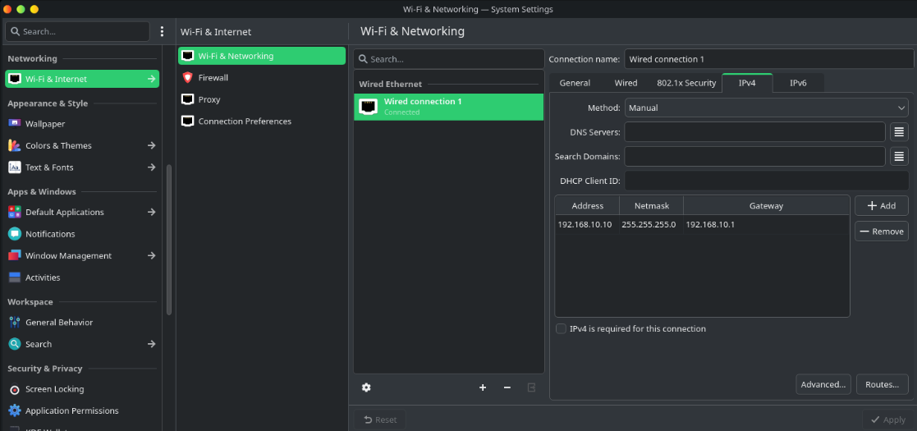

Step 5 : Similarly set the ip and default gateway for the Metasploitable using the below command:
sudo ifconfig eth0 192.168.20.10 netmask 255.255.255.0 up
sudo route add default gw 192.168.20.1

Step 6 : configure ping rule in pfSense so that parrot OS can ping metasploitable through firewall
- Open the pfSense application using the configured IP.
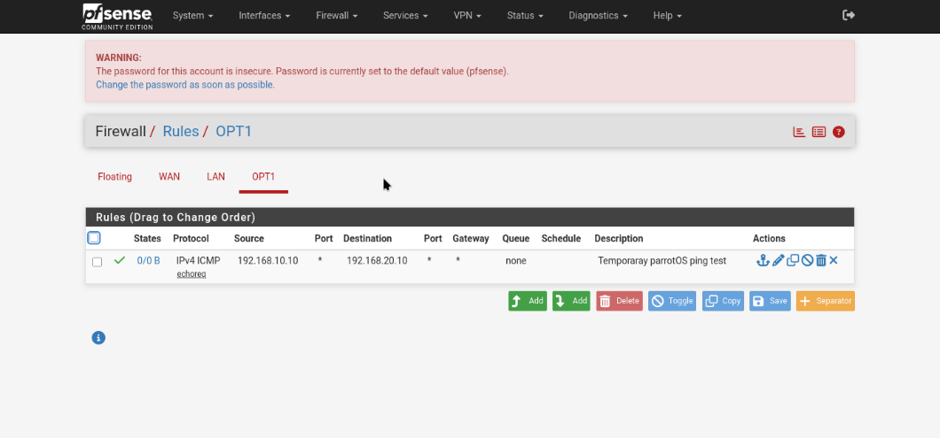
- Set the rule as below:

Step 7 : Configure the wazuh siem in another VM here in ubuntu 24.04 server(wazuh will only work smoothly on this version of ubuntu server). Make sure the ubuntu and parrot os in the same network ip so that it can communicate with the firewall.
Step 8: configure the enp0s8 adapter to the same IP as the attacker VM with the below commands.
- sudo nano /etc/netplan/50-cloud-init.yaml
- Replace the existing contents with this configuration:
network:
version: 2
ethernets:
enp0s3:
dhcp4: true
enp0s8:
dhcp4: false
addresses:
- 192.168.10.20/24
- Save the same and exit
- sudo netplan generate
- sudo netplan apply

Step 9 : install wazuh in the ubuntu server using the below commands so that all the wazuh components(manager, indexer, and dashboard) will be installed.
- curl -sO https://packages.wazuh.com/4.14/wazuh-install.sh
- ls -lh wazuh-install.sh (valigating whether the file downloaded or not.)
- sudo bash ./wazuh-install.sh -a
Step 10 : connect wazuh and pfSense so that the firewall logs are ingested to wazuh. Configure the remote syslog destination as follows:
- Enable Remote Logging: checked
- Remote log server: 192.168.10.20:514
- Protocol: UDP, if selectable
- Log categories: Firewall events at minimum; include other useful system events if available
Step 11: check if syslog receiver is enabled in ubuntu wazuh using the below command:
sudo grep -n -A 12 '<remote>' /var/ossec/etc/ossec.conf
output looks like:
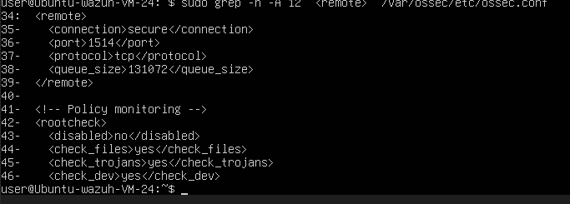

Step 12: test the wazuh log analysis decoder. Inorder to do the same in the wazuh vm edit the local_decoder.xml to the below xml :
“”
<decoder name="pfsense-filterlog">
<prematch type="pcre2">filterlog\[\d+\]:</prematch>
<regex type="pcre2">^.*filterlog\[\d+\]:\s*\d+,\d+,,\d+,[^,]+,[^,]+,(pass|block),[^,]+,\d+,[^,]*,[^,]*,\d+,\d+,\d+,[^,]*,\d+,([^,]+),\d+,([0-9A-Fa-f:.]+),([0-9A-Fa-f:.]+),(\d+),(\d+),</regex>
<order>action, protocol, srcip, dstip, srcport, dstport</order>
</decoder>
“”
Validate the xml:
“”
sudo /var/ossec/bin/wazuh-analysisd -t
“”
Start the log test :
“”
sudo /var/ossec/bin/wazuh-logtest
“”
Paste the full log from wazuh after the command

Step 13: Modify the rules and add your own rules to the xml.
“”
sudo cat /var/ossec/etc/rules/local_rules.xml

“”
Add a below new rule to the xml (this will generate a new alert in the wazuh when the pfsense firewall detects the block alert.)
“”
<group name="pfsense,firewall,">
<rule id="100500" level="5">
<decoded_as>pfsense-filterlog</decoded_as>
<action>block</action>
<description>pfSense firewall blocked network traffic.</description>
<group>pfsense,firewall,blocked_traffic,</group>
</rule>
</group>
Test the same with a sample alert.

Step 14: once the test alert is success, perform a TCP connection attempt using the below command.
“”
nc -vz -w 3 192.168.20.10 22
“”
Check for the alerts in pfSense firewall logs, in wazuh server and also in the wazuh dashboard.
If yes the pipeline is working fine. We can proceed with the remaining steps.
Step 15: now add the port scan detection rule.
Open the local_rules.xml and add the below:
“”
<rule id="100501" level="10" frequency="10" timeframe="60">
<if_matched_sid>100500</if_matched_sid>
<protocol>tcp</protocol>
<same_srcip />
<same_dstip />
<same_protocol />
<different_dstport />
<description>Possible TCP port scan: multiple destination ports probed by the same source.</description>
<group>pfsense,firewall,port_scan,network_scan,</group>
</rule>
“”
The above rule will check for the tcp connection attempt that is being done 10 times within 60sec. when it detects that the alert will generated. (this has a connection to the rule:100500)
Step16: check the wazuh alerts page for rule id 100501 if it appears then we can confirm the multiple port scan alert is captured in wazuh.
Our completed detection timeline looks like the below:
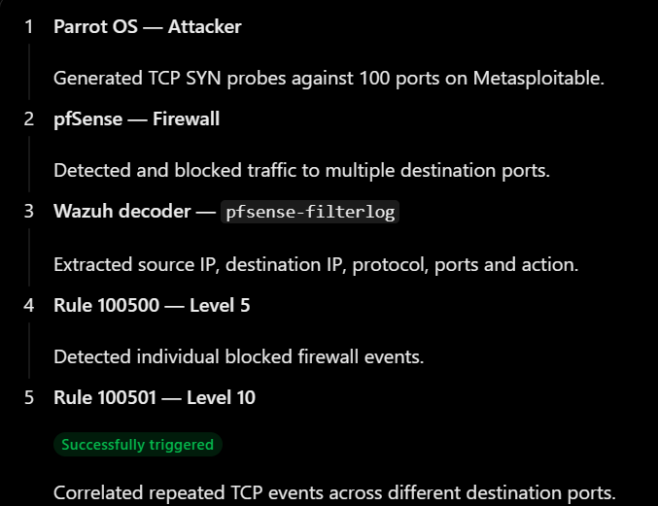

Using the detection lab we are able to investigate and analyze the threat.

==================END LAB===================

